
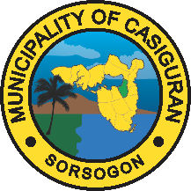
Republic of the Philippines
Province of Sorsogon
MUNICIPALITY OF CASIGURAN

NOTIFICATION OF LOWEST CALCULATED BID

______________

{{title_upper}}. {{proprietor_upper}}
Proprietor //Owner
{{company_name_upper}}
City Employees Village, Cabid-An, Sorsogon

Dear Ma’am/Sir,

We are pleased to inform you that per Line Bid Evaluation of submitted Bid Proposal for the {{project_title_upper}}, your line bids are the lowest calculated bids.

Thus, you are hereby advised/required to submit the following documents within five (5) calendar days upon receipt hereof:
1. 3 sets of Bidding Documents
Upon Submission of this document, we will conduct post qualification evaluation to examine, validate and verify the eligibility and technical documents that you have submitted for the bidding.
Please be guided accordingly.

Very truly yours,

ARLIE H. CORAÑES
BAC CHAIRMAN

Received by the Bidder:

{{proprietor_upper}}
{{company_name_upper}}

Date: {{date}}

